Audit consistency/uniformity

Here in this we have validated the uniformity of the data using two test cases for customer database.

1. Where we validated the email id of the customers with ‘@’ symbol and without ‘@’ symbol and represented them in a bar graph.

We have a python code for the same,

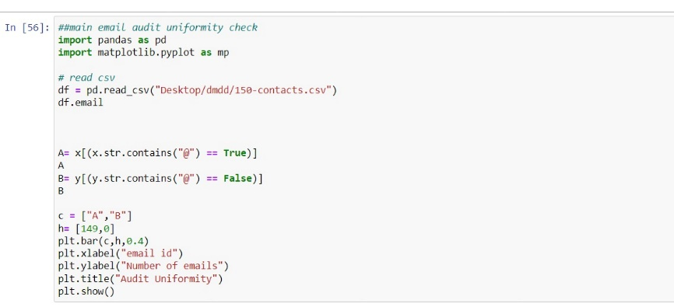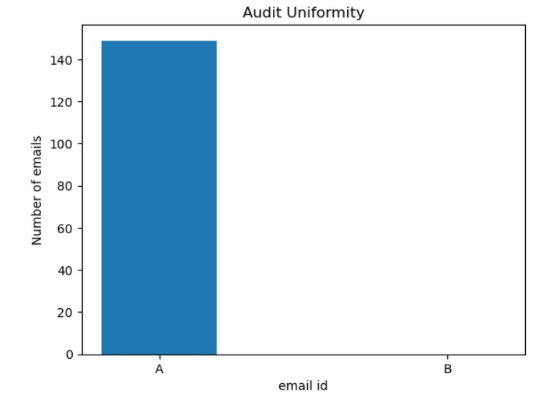

We can see that there are no email id without @ symbol in the customer data.

2) Where we validated the phone number of the customers with less than 10 digits and the numbers which is equal to 10 digits and represented them in a bar graph.

We have a python code for the same,

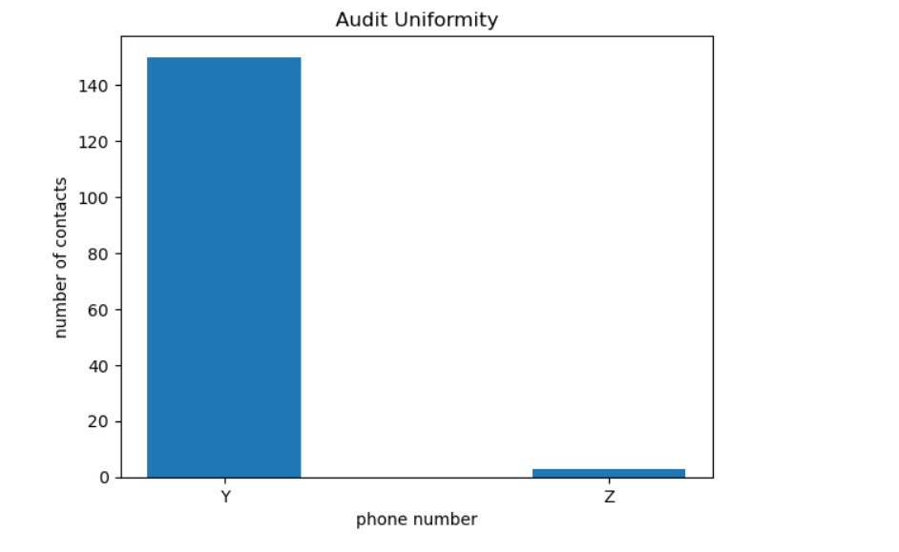

Here we can see that out of 149 customer data we have 3 phone numbers that are less that 10 digits ,which does not satisfy the criteria.

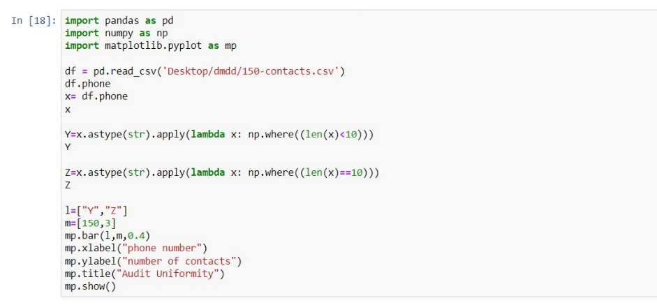

Audit Accuracy

We have the code and the result for audit accuracy here.

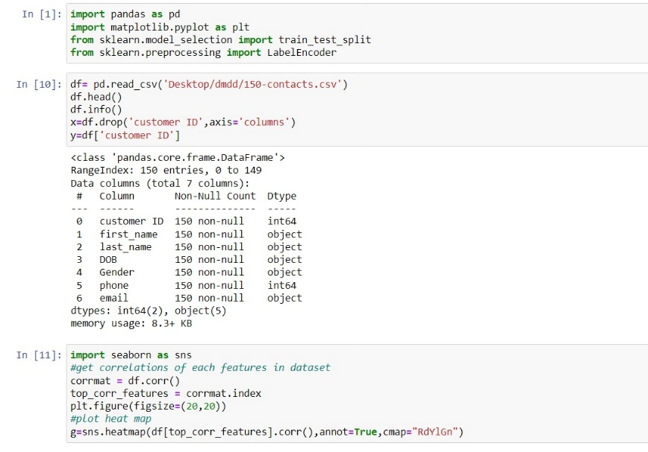

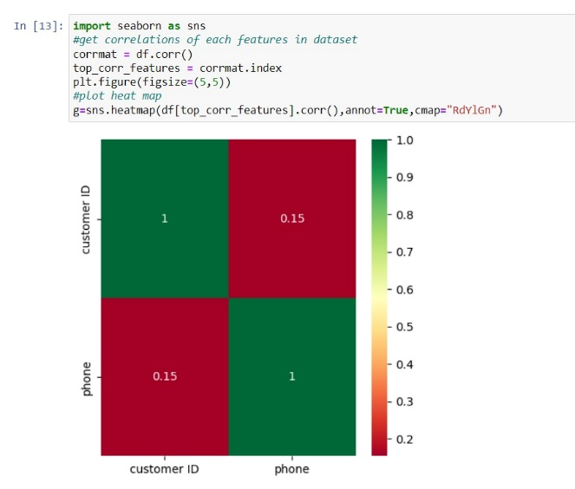

We also have a heatmap for the same.